Joseph Silva Jr.

08/15/21

CS 350 – Project

SNHU

A wireless thermostat is able to sense the temperature within the surrounding area using electronic sensors to communicate with its system to display accurate information to a user or individual. For this class, we used CS 3220 MCU for the development of a smart thermostat, which we can see within certain code such as I2C driver which returns temperature information. The wireless smart thermostat uses the CS 3220 SimpleLink Wi-Fi microcontrollers (MCUs) to conduct many tasks such as “the thermostat should have the ability to sense a variety of sensors like temperature, humidity, pressure, ambient light, air quality and proximity sensors” (1) and “it must have remote configurability and control when the user isn’t home” (1). A thermostat operated by a SimpleLink MCU is able to be controlled by a user due to the built in Wi-Fi and this allows the thermostat to be connected to a cloud system through features like geofencing. Please see the diagram below which shows the application MCU and the network process of the CS 3220.

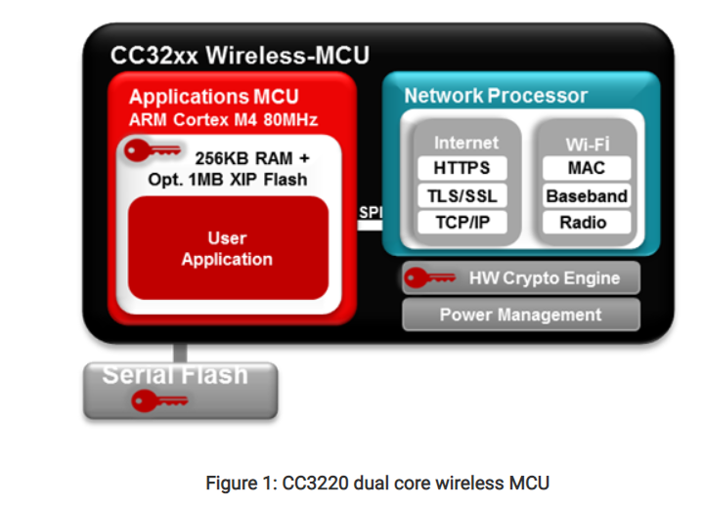

.

While reviewing resources, I found information on Microchip's LCD-Drive Microcontroller, **Freescale's 45-nm Communications' Processor, and** TI's Real-Time Microcontroller. (2) Microchip LCD-Drive Microcontroller is an 8-bit MCU which features 64-128KB Flash and 4KB RAM. The LCD-Drive includes RTCC, which is real time clock and calendar, and CTMU, which is charge time measurement unit, for precise time measurement. Next, the Freescale is a high performance and low powered device aimed for wireless or wired communication. “It's designed to address ever-increasing performance and protocol support requirements, as well as demand for low-cost operation for broadband access equipment, such as 3G/WiMAX/LTE base stations, RNCs, gateways and ATM/TDM/IP equipment”. Lastly, the TI or Texas Instrument Real-Time Microcontroller are MCUs allow real time control to cost sensitive applications. The TI’s “real-time performance makes the device a candidate for industrial, consumer and automotive applications, such as solar power micro-inverters, LED lighting, white goods appliances, power line communications and hybrid automotive batteries” (2).

**CITATION:**

1. *Being smart isn't enough for Thermostats today*. Embedded processing - Technical articles - TI E2E support forums. (n.d.). <https://e2e.ti.com/blogs_/b/process/posts/being-smart-isn-t-enough-for-thermostats-today>.
2. 15, D. N. S. | A. (2017, May 22). *Freescale, microchip, TI roll OUT MICROCONTROLLERS*. designnews.com. https://www.designnews.com/freescale-microchip-ti-roll-out-microcontrollers-0.
3. *SimpleLink™ Wi-Fi® AT Command User's Guide*. (n.d.). https://www.ti.com/lit/ug/swru534d/swru534d.pdf?ts=1629441560442&ref_url=https%253A%252F%252Fwww.ti.com%252Ftool%252FCC3220S-LAUNCHXL.